# Computer Organization and Assembly Language

**FALL 2020**

# Project

**Deadline of complete project is 18 December 2020 no late submission will be accepted.**

# Image result for super mario

Super Mario is a Nintendo Entertainment System video game released in 1985 by Nintendo. The game has become one of the most important and successful video game in that time. It is the one of the favorite game of children of that era. In Super Mario, the character Mario sets off on an adventure to save the beautiful Kingdom. The game was divided in different levels, where each level is harder than the previous level. Mario has to pass through several hurdles, and also encounter different enemies at each level. After certain level, Mario has to save kingdom from the monster who has the kingdom. Further, monster throw different objects to stop the Mario from reaching the kingdom.

In this project you have to develop a *mini* version of the Super Mario on the console using Assembly language. You have to develop three different levels of game. The description of each level has been given below.

Other than these three levels you have to also make game start and end screens. First of all start screen will show up the name of the game, followed by the screen that asks for username. At the end, the screen should show the score, level and *Win* or *Lose*.

**Level 1** 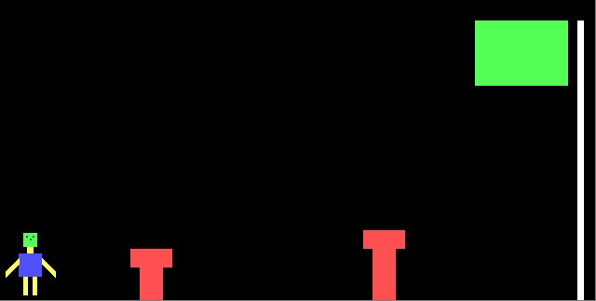

At Level 1, you have to create the character of Mario, hurdles and Flag (on the top right of the screen). Mario will start running from the right side of the screen (using left-right arrow keys) towards the flag and jump over the hurdles (using up arrow key). When Mario reaches the flag, level will be completed and you have to start the next. Below is example screenshot.

*This screen is made just to elaborate the level 1 more conveniently. Things that you have to do mentioned below.*

You are required to implement following things:

* Mario Character
  + Proper body of Mario similar to the one in screenshot.
  + Use special characters to design appropriate Mario character.
* Hurdles
  + You have to draw at least three hurdles of different sizes.
  + You can draw hurdles as you want but not less than three hurdles.
* Flag
  + Flag should be at right most side.
  + You have to draw Moon and Star (or other similar characters) in the green part of flag.
* Movement
  + To move Mario, use the left and right arrow keys.
  + It can jump using up key to pass the hurdle.

**Level 2**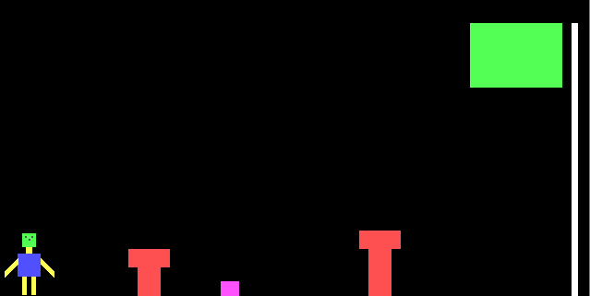

At Level 2, all the things you have done in Level 1 should remain the same, and you have to add enemies between the hurdles. Enemies move between hurdles.

The pink box represents the enemy.

You are required to implement following concepts:

* Enemy Character
  + You have to draw enemy character which resembles with the following Mario enemy character.

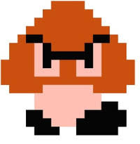

* + You can create triangle with the legs and eyes but it should be appropriate.
  + Create at least two enemies.
* Enemy Movement
  + Enemies should move between the hurdles left and right.
* Enemy Collision
  + You have to detect the collision with the enemy which will result in death of Mario.

**Level 3**

At Level 3, all the things you have done in Level 2 should remain the same, and have to add monster and replace flag with the kingdom in the scene.

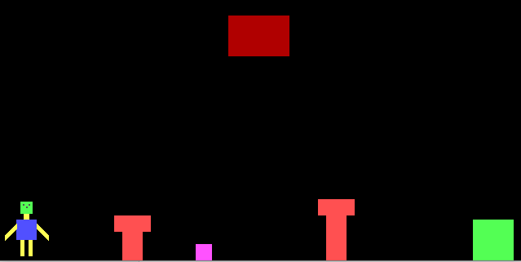

Red box is representing monster and green box is represent kingdom.

You are required to implement following things:

* Monster
  + You have to create monster which fly at the top of the scene.
  + It throw objects to stop Mario from reaching kingdom
  + If monster thrown objects collide with Mario game will over.
  + Monster Character for reference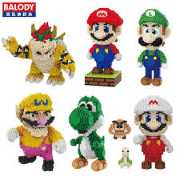
  + Monster move left and right on the top.
* Kingdom
  + You have to create appropriate kingdom.

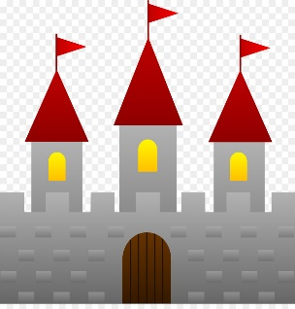

**Instructions:**

* You are required to work in MASM. Project incompatible of MASM will not be considered.
* A group of maximum size **three** is allowed.
* Cross Section groups are **not** allowed.
* User Interface is important in this project. Try to develop an attractive user interface.
* Use of extra features in the project is encouraged.
* Use good programming practices (well commented and indented code; meaningful variable names, readable code etc.).
* Only one group of the student submit the project in Zip File.
* Copy/cheating case will be awarded an “F” grade in the course.

Good luck ☺